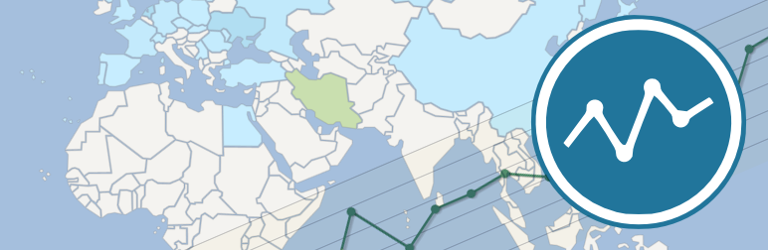

WP Statistics

Administrator Manual

Version 9.3

Table of Contents
Introduction 3
Features 4
Requirements 5
Frequently Asked Questions 6
Support 12
Installation 13
Removal 13
Manual Removal 14
Main Interface 15
Dashboard Widgets 17
Manual Page 18
Settings Page 19
Optimization Page 38
Overview Page 47
Browsers Page 50
Countries Page 51
Exclusions Page 52
Hits Page 53
Online Page 54
Pages Page 55
Referrers Page 57
Searches Page 58
Search Words Page 59
Top Visitors Today 60
Visitors Page 61
Multi-Site 62
The Widget 64
Shortcodes 65
Function API 67

Introduction
Welcome to WP Statistics!
This plug-in is designed to track your visitor statistics in WordPress, completely locally without any external services.
You can find us on the web at http://wp-statistics.com.
There are several key items to note about WP Statistics:
- No external services are required, all code and data runs locally on your system.
- Aggregate data is stored whenever possible, when specific data is required (like IP addresses for visitors) only the date is stored with the hit, not the time.
- This product includes GeoLite2 data created by MaxMind, available from http://www.maxmind.com.

This document will use a couple of conventions you should be aware of:
- Screen shots will generally exclude all of the WordPress admin menus to keep them concise.
- Menu selections and other actions to be taken will be indicated with italics.
- If multiple menu selections are required, they will be separated with ->, so for example if you are to go to the settings page, this document will indicate it with Statistics->Settings.
- If a page has tabs on it, they will be treated as menu items, so for example, if you are to go to the GeoIP tab on the Settings page, this document will indicate it with Statistics->Settings->GeoIP.
- In some sections you will find a “Developers Note”, these are items that a developer may find useful if they are looking to work with WP Statistics, normal administrators or users can safely ignore these items.

Features
WP Statistics has many features:
- User Online, see how many people are currently viewing your site
- Visits, see how many hits your site gets each day
- Visitors, see who's visiting your site
- Page tracking, see which pages are viewed most often
- Search Engines, see search queries and redirects from popular search engines like Google, Bing, DuckDuckGo, Yahoo, Yandex and Baidu
- GeoIP location by Country
- Support for not storing IP addresses in the database
- Interactive map of visitors location
- E-mail reports of statistics
- Set access level for view and manage roles based on WordPress roles
- Exclude user roles from statistics collection
- Exclude robots from statistics collection
- Exclude IP subnets from statistics collection
- Exclude login/admin pages from statistics collection
- Record statistics on exclusions
- Automatic updates to the GeoIP database
- Automatically prune the databases of old data
- Export the data to Excel, XML, CSV or TSV files
- Overview and detail pages for all kinds of data, including; browser versions, country stats, hits, exclusions, referrers, searches, search words and visitors
- Widget to provide information to your users
- Shortcodes for many different types of data in both widgets and posts/pages
- Dashboard widgets for the admin area

Requirements
WP Statistics requires a few things to work:
- WordPress 3.0 or above
- PHP 5.3 or above
- MySQL 5.0 or above

WP Statistics might work on older versions of the above software, but then again, it might not (it does NOT function on any PHP versions before 5.3).

The GeoIP support also requires a few additional items to function:
- the cURL extension for PHP
- PHP cannot be running in safe mode

WP Statistics requires a significant amount of RAM for the statistics pages, especially the overview page, make sure to set your PHP memory limit high enough to support it. While every site has different memory requirements, a reasonable rule of thumb is at least 36 megabytes and significantly higher is not unreasonable (128-256 megabytes).

Frequently Asked Questions

Where's the Admin Manual?
The admin manual is installed as part of the plugin, simply go to Statistics->Manual to view it. At the top of the page will also be two icons that will allow you to download it in either ODT or HTML formats.

What do I do if the plug does not work?
Disable / Enable the plugin. You may also want to remove and re-install it.

All visitors are being set to unknown for their location?
Make sure you've downloaded the GeoIP database and the GeoIP code is enabled.
Also, if your running an internal test site with non-routable IP addresses (like 192.168.x.x or 172.28.x.x or 10.x.x.x), these addresses will come up as unknown always.

I was using V3.2 and now that I've upgraded my visitors and visits have gone way down?
The webcrawler detection code has been fixed and will now exclude them from your stats, don't worry, it now reflects a more accurate view of actual visitors to your site.

GeoIP is enabled but no hits are being counted?
The GeoIP code requires several things to function, PHP 5.3 or above, the bcmath extension, the cURL extension and PHP cannot be running in safe mode. All of these conditions are checked for but there may be additional items required. Check your PHP log files and see if there are any fatal errors listed.

How much memory does PHP Statistics require?
This depends on how many hits your site gets. The data collection code is very light weight, however the reporting and statistics code can take a lot of memory to process. The longer you collect data for the more memory you will need to process it. At a bare minimum, a basic WordPress site with WP Statistics should have at least 32 meg of RAM available for a page load. Sites with lots of plugins and high traffic should look at significantly increasing that (128 to 256 meg is not unreasonable).

I've enabled IP subnet exclusions and now no visitors are recorded?
Be very careful to set the subnet mask correctly on the subnet list, it is very easy to catch too much traffic. Likewise if you are excluding a single IP address make sure to include a subnet mask of 32 or 255.255.255.255 otherwise the default subnet of 0 will be used, catching all ip addresses.

I'm not receiving e-mail reports?
Make sure you have WordPress configured correctly for SMTP and also check your WP Cron is working correctly. You can use Cron View to examine your WP Cron table and see if there are any issues.

Does WP Statistics support multi-site?
WP Statistics hasn't been tested with multi-site and there have been some issues reported with getting it enabled correctly on all sites in a network.
Version 8.8 is the first release that should install, upgrade and remove correctly on mutli-site as well as have some very basic support for the network admin menu. This should not be taken as an indication that WP Statistics fully support for multi-site, but only as a very preliminary first step.

Does WP Statistics report on post hits?
Yes, version 6.0 has introduced page hit statistics!

Does WP Statistics track the time of the hits?
No.

The GeoIP database isn't downloading and when I force a download through the settings page I get the following error: "Error downloading GeoIP database from: http://geolite.maxmind.com/download/geoip/database/GeoLite2-Country.mmdb.gz – Forbidden"
This means that MaxMind has block the IP address of your webserver, this is often the case if it has been blacklisted in the past due to abuse.
You have two options:
- Contact MaxMind and have them unblock your IP address
- Manually download the database
To manually download the database and install it take the following steps:
- On another system (any PC will do) download the maxmind database from http://geolite.maxmind.com/download/geoip/database/GeoLite2-Country.mmdb.gz
- Decompress the database
- Connect to your web host and create a "wp-statistics" directory in your wordpress uploads folder (usually it is located in wp-content, so you would create a directory "wp-content/uploads/wp-statistics").
- Upload the GeoLite-Country.mmdb file to the folder you just created.
You can also ask MaxMind to unblock your host. Note that automatic updates will not function until you can successfully download the database from your web server.

I've activated the plugin but the menus don't show up and nothing happens?
WP Statistics requires PHP 5.3, if it has detected an older version of PHP installed it will active but it will display an error on your plugin list just below the WP Statistics entry to let you know.
If there is no error message there may be something else wrong, your first thing to try is disabling your other plugins as they can sometimes cause conflicts.
If you still don't see the menus, go to the support forums and open a new thread and we'll try to help out.

I'm using another statistics plugin/service and get different numbers for them, why?
Pretty much every plugin/service is going to give you different results for visits and vistors, there are several reasons for this:
- Web crawler detection
- Detection method (javascript vs server side PHP)
- Centralized exclusions
Services that use centralized databases, like Google Analytics, for spam and robot detection have better detection than WP Statistics can. The trade off of course is relaying on an external service.

Something has gone horribly wrong and my site no longer loads, how can I disable the plugin without access to the admin area?
You can manually disable plugins in WordPress by simply renaming the folder they are installed in. Using FTP or your hosting providers file manager, go to your WordPress directory, from ther go to wp-content/plugins and rename or delete the wp-statistics folder.

I'm getting an error in my PHP log like: Fatal error: Call to undefined method Composer\Autoload\ClassLoader::set()
We use several libraries and use a utility called Composer to manage the dependencies between them. We try and keep our Composer library up to date but not all plugins do and sometimes we find conflicts with other plugins. Try disabling your other plugins until the error goes away and then contact that plugin developer to update their Composer files.

The search words and search engine referrals are zero or very low, what's wrong?
Search Engine Referrals and Words are highly dependent on the search engine providing the information to us and that often is not the case. Unfortunately there is nothing we can do about this, we report on everything we receive.

Why did my visits suddenly jump way up today?
There can be many reasons for this, but the most common reason is a botnet has decided to visit your site and we have been unable to filter it out. You usually see your visits spike for a few days and then they give up.

What’s the difference between Visits and Visitors?
Visits is the number of page hits your site has received.
Visitors is the number of unique users that have visited your site.
Visits should always be greater than Visitors (though there are a few times when this won’t be true on very low usage sites due to how the exclusion code works).
The average number of pages a visitor views on your site is Visits/Visitors.

My overview screen is blank, what's wrong?
This is usually caused by a PHP fatal error, check the page source and PHP logs.
The most common fatal error is an out of memory error. Check the Statistics->Optimization page and see how much memory is currently assigned to PHP and how much the overview is using.
If it is a memory issue you have two choices:
- Increase PHP's memory allocation
- Delete some of your historical data.
See http://php.net/manual/en/ini.core.php#ini.memory-limit for information about PHP's memory limit.
To remove historical data you can use the Statistics->Optimization->Purging->Purge records older than.

Not all referrals are showing up in the search words list, why?
Unfortunate we're completely dependent on the search engine sending use the search parameters as part of the referrer header, which they do not always do.

Support
We're sorry you're having problem with WP Statistics and we're happy to help out. Here are a few things to do before contacting us:
- Have you read the FAQs?
- Have you read the manual?
- Have you search the support forum for a similar issue?
- Have you search the Internet for any error messages you are receiving?

And a few things to double-check:
- How's your memory_limit in php.ini?
- Have you tried disabling any other plugins you may have installed?
- Have you tried using the default WordPress theme?
- Have you double checked the plugin settings?
- Do you have all the required PHP extensions installed?
- Are you getting a blank or incomplete page displayed in your browser? Did you view the source for the page and check for any fatal errors?
- Have you checked your PHP and web server error logs?

Still not having any luck? Open a new thread on one of the support forums and we'll respond as soon as possible.
- English Support Forum
- Persian Support Forum

Installation
Installation is straight forward, you can either use WordPress' built in installation process or manually upload the files to the WordPress plugin directory.
Once installed, go to the WordPress plugin page and activate WP Statistics.
You should then configure the settings found in the following sections, at a minimum, check the sections on the GeoIP, browscap and exclusions.

Removal
If you wish to remove WP Statistics, you can do so using the standard WordPress tools, however WP Statistics will NOT delete the statistical data or settings from the database using this method.
You can remove the data and settings by going in to the Statistics->Settings->Removal tab and checking the “Remove data and settings” option. This will delete all tables and settings and effectively disable the plugin.
You can then go to WordPress plugins page and disable/delete it completely from your site.

Manual Removal
If you have to manually delete the plugin you can do so if you have access to phpMyAdmin or another SQL management tool on your hosting provider.
NOTE: You should not attempt to manually remove the plugin unless it is absolutely necessary and only if you understand all the steps involved.
First, delete the plugin files which can be found in your WordPress/wp-content/plugins/wp-statistics folder.
Next remove the data from the database, for this example we will assume you have not changed your WordPress database prefix and are not running multi-site. If your prefix is different or you are running multi-site you will need to run each of the commands with the appropriate database table names.
Execute the following SQL commands:
- DELETE FROM `wp_options` WHERE `option_name` LIKE 'wp_statistics%'
- DELETE FROM `wp_usermeta` WHERE `meta_key` LIKE 'wp_statistics%'
- DROP TABLE IF EXISTS wp_statistics_useronline, wp_statistics_visit, wp_statistics_visitor, wp_statistics_exclusions, wp_statistics_pages, wp_statistics_historical

Main Interface
WP Statistics adds a top level menu to your admin interface in PHP, you should see like this in your main admin page:
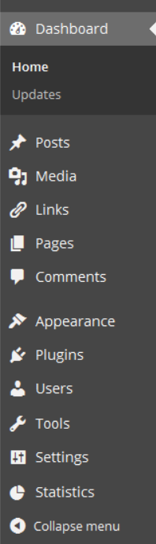
The Statistics menu will be located near the bottom of the list, clicking on it should bring up the following additional items:
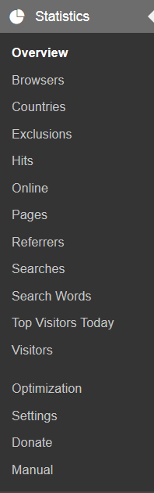
Each of these options will be discussed in the following sections.
In addition, if you've enabled the option, you may also see the WP Statistics menu icon in the main admin bar of your site as such:
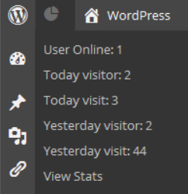
This menu gives you a quick summary of what is going on with your site and direct access to the overview page of WP Statistics.

Dashboard Widgets
WP Statistics includes a number of dashboard widgets you can add if you have read access to WP Statistics.
Much like the overview page, if you have enabled multiple of the widget you may have a significant performance impact on you dashboard load time. You can disable the dashboard widgets in the Statistics->Settings->Dashboard/Overview if you find your site can not handle the widgets.
By default, the dashboard widgets are not displayed, with the exception of the Quick Stats widget. Users can individually enable them through the “Screen Options” drop down in the WordPress dashboard.
Due to the overhead in generating the widgets, if a widget is not visible during the initial dashboard load a placeholder message, “Please reload the dashboard to display the content of this widget. ”, will appear in the widget if it is turned on until the dashboard is reloaded.
The dashboard widgets mirror the Overview page widgets with the following exceptions/notes:

Widget | Description
Quick Stats | This combines the visit/visitor stats from the summary widget and the hits graph for the last ten days. Note, only one hits graph can be displayed per page so if you have enabled the Hits widget the Quick Stats widget will not display the hits graph.
About | This widget is not available on the dashboard.
Hits Statistics | Due to space limitations, only 10 days are displayed.
Search Engine Referrals | Due to space limitations, only 10 days are displayed.

Manual Page
The manual page gives you access to the release version of this document.
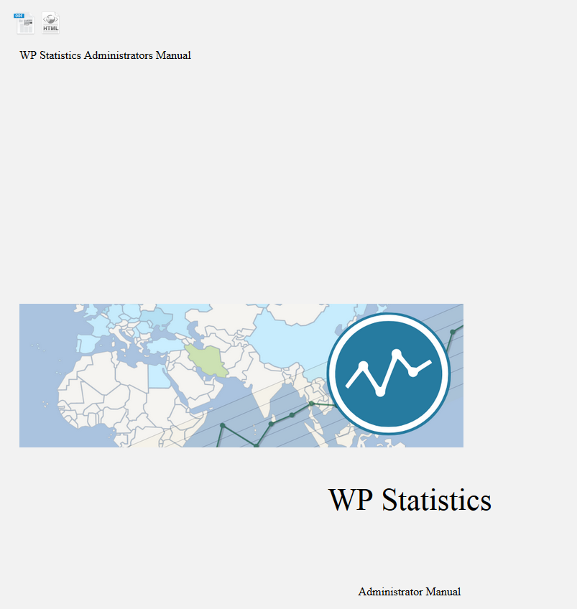
You will be given access to the online version of the document which you can read, or the two icons at the top of the page will allow you to download a copy of the manual to read offline or print for your reference.
There are two formats available to download, the first is a OpenOffice/LibreOffice ODT file and the second is an HTML file.

Settings Page
The first thing you should do after installing WP Statistics is configure the plug-in, this is accomplished through the settings page.
Simply go to Statistics->Settings to get there. The main settings page looks like this:
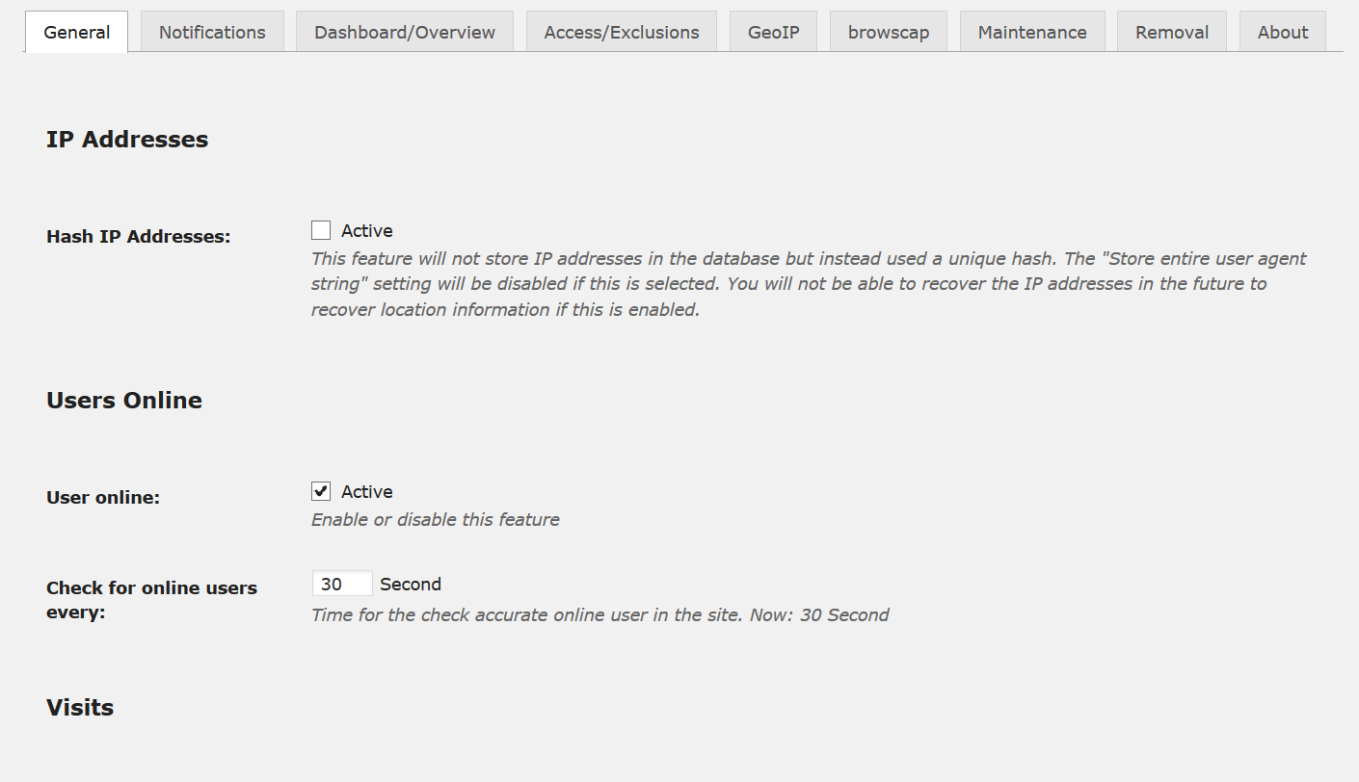
At the top are nine tabs, each one will be addressed separately.

General Settings
The General Settings page has 9 subsections to it; Users Online, Visits, Visitors, Pages, Miscellaneous, Search Engines, Charts, Map and Statistical reporting.

IP Addresses
The IP Addresses section contains the configuration items IP storage in WP Statistics. Note has a long term impact to your site.
Setting | Values | Description
Hash IP Addresses | On/Off | This feature will not store IP addresses in the database but instead used a unique hash. The "Store entire user agent string" setting will be disabled if this is selected.  You will not be able to recover the IP addresses in the future to recover location information if this is enabled.  Once enabled all new visitors to your site will have their IP addresses stored as a hash, however previous visits will not be converted and you may want to purge your old data.  You can also got to Statistics->Optimization->Updates and select “Hash IP Addresses” to update old entires in the database.

Users Online
The Users Online section contains the configuration items tracking online users in WP Statistics.
Setting | Values | Description
User Online | On/Off | This enables/disables the tracking of users that are online for your site.
Check for online users every | Number | If you have enabled Users Online tracking, this is how often they are checked for. If a user has not visited a page within this number of seconds, they will be considered offline.

Visits
The Visits section contains the configuration items for tracking visits (hits) to your site.
Setting | Values | Description
Visits | On/Off | This enables/disables the tracking of visits (hits) for your site.

Visitors
The Visitors section contains the configuration items for the visitor tracking for your site.
Setting | Values | Description
Visitors | On/Off | This enables/disables the tracking of visitors for your site.
Store entire user agent string | On/Off | If you have enabled Visitors, by default it stores the browser make, version and platform in the database by parsing the user agent (UA) string. However UA strings are very complex and parsing sometimes does not work correctly. You can store the entire UA string in the database so that it can used to troubleshoot issues.
Coefficient per visitor | Number | This is the number of hits each visitor records for. Usually is 1, however if you have another plug-in that causes visitors to effectively connect to to your site more than once for each page view, this can be set to a lower value to account for that.

Pages
The Pages section contains the configuration items for the page tracking code.
Setting | Values | Description
Pages | On/Off | This enables/disables the tracking of individual page hits.
Track all pages | On/Off | By default, page tracking only tracks WordPress pages and posts, however you can enabled tracking of all pages (like category pages, RSS feeds, etc.) with this option.  Note: this will significantly increase the pages table and may make the top pages chart less useful as many system pages will likely be near the top.
Strip parameters from URI | On/Off | By default the page tracking code tracks every unique URI, including the parameters after the ?. This can cause the same page to be tracked as multiple unique URI's which may not be appropriate.  This option cannot be activated if you are using the default setting for permalinks in WordPress. Likewise if your permalink setting contains a ? then this option will not be available.  You should only enable this option if you fully understand the consequences. For example, the default behaviour of WP Statistics is to track multi-page posts separately so you can see if a user reads more than one page. Enabling this option will not track these pages separately.
Disable hits column in post/pages list | On/Off | By default, if Pages is enabled, WP Statistics will add a column to the post and pages lists in WordPress and display the number of hits each one has had. This does have a performance impact and this option will disable this behaviour.

Miscellaneous
The Miscellaneous section contains configuration items for WP Statistics.
Setting | Values | Description
Show stats in menu bar | Yes/No | This enables/disables the admin menu bar for WP Statistics.  Note: As the WP Statistics menu bar displays visitor stats, it adds load to your database for each admin page load.
Hide admin notices about non active features | On/Off | By default, WP Statistics will warn you about any primary features that have been disabled (Online Users, Visits, Visitors, Pages and GeoIP). If you have disabled a feature on purpose or cannot support the GeoIP code, this option will remove the warning.
Delete the manual | On/Off | By default WP Statistics stores the admin manual in the plugin directory (~5 meg), if this option is enabled it will be deleted now and during upgrades in the future.

Search Engines
The Search Engines section contains the options for which search engines you want to track. By default all supported search engines are enabled, you may disable individual ones as required.
Note however that disabling all search engines is not allowed, doing so will result in all search engines being active.
Setting | Values | Description
Baidu | On/Off | Enable/disable Baidu.
Bing | On/Off | Enable/disable Bing.
clearch.org | On/Off | Enable/disable clearch.org.
DuckDuckGo | On/Off | Enable/disable DuckDuckGo.
Google | On/Off | Enable/disable Google.
Yahoo! | On/Off | Enable/disable Yahoo!.
Yandex | On/Off | Enable/disable Yandex.

Also note that geographic versions of the search engines are supported, so Google will include google.com as well as google.ca and other variations.
Developers Note:
The search engine list can be found in wp-statistics\includes\functions\functions.php in the function called wp_statistics_searchengine_list() (should be around line 297). You can add additional search engines by editing the $engines array, details are contained in the comments above the function. All other aspects of the search engine code relies on this array and no other aspects of WP Statistics needs to be changed to support the addition or removal of search engines.

Charts
The Charts section contains the options for the display of charts in WP Statistics.
Setting | Values | Description
Include totals | On/Off | By default WP Statistics does not include totals in charts that have multiple values in them, this options enables a total value on any chart that supports them.

Languages
The Languages section contains the options for the language used in WP Statistics.
Setting | Values | Description
Force English | On/Off | By default WP Statistics uses the language that the WordPress administrative console is set to to display all strings. This setting will override that behaviour and instead use English.

Notifications

Common Report Options
The Common Report Options section contains options that are common to all of the sections that follow.
Setting | Values | Description
E-mail addresses | Comma separated list | This is a comma separated list of e-mail addresses to send the report too if e-mail was selected in the option above. By default this will be the WordPress admin e-mail address.

Update Reports
The Update Reports section contains options for when to send e-mail notifications when various update actions occur.
Setting | Values | Description
Browscap | On/Off | Send a report whenever the browscap.ini is updated. See the browscap tab to enable automatic updates.
GeoIP | On/Off | Send a report whenever the GeoIP database is updated. See the GeoIP tab to enable automatic updates.
Pruning | On/Off | Send a report whenever the pruning of database is run. See the Maintenance tab to enable automatic pruning.
Upgrade | On/Off | Send a report whenever the plugin is upgraded.

Statistical Reporting
The Statistical Reporting section contains the options to email the administrators the statistics.
Note if reporting is disabled, all other related fields will be hidden in the user interface.
Setting | Values | Description
Statistical reporting | On/Off | Enable/disable the reporting.
Schedule | Hourly/  Twice Daily/  Daily/  Weekly/  Bi-Weekly/  Every 4 Weeks | How often to send the report.
Send reports via | Email/SMS | How to send the report, the blog's admin email address is used if email is selected.  To support SMS you must have WordPress SMS (http://wordpress.org/plug-ins/wp-sms/) installed as well.
Report body | Text | This is the report text which will be sent, you can use any short codes supported by your installation of WordPress, including the ones from WP Statistics.  As of WP Statistics 8.0 the old variables have been removed and the upgrade process will automatically replace them with the appropriate short codes.

Dashboard/Overview
The Overview page has 3 subsections to it; Map, Post/Page Editor and Widgets to Display.

Dashboard
The Dashboard section contains the options for the display of the dashboard widgets.
Setting | Values | Description
Disable dashboard widgets | On/Off | If you wish to disable the dashboard widgets for all users, you can do so by enabling this option.

Post/Page Editor
The Post/Page Editor section contains the option for the widget on the post/page editor in WordPress.
Setting | Values | Description
Disable post/page editor widget | On/Off | WP Statistics will include a 20 days page hit chart on the post and page editor screens in WordPress. This option will disable this for your site.

Map
The Maps section contains the options for the display of the GeoIP map in the overview page of WP Statistics.
Setting | Values | Description
Map type | Google/  JQVMap | There are two mapping libraries available, Google and JQVMap. Use of the Google map library will access the Google servers to get the library and create push pins with details for each country on it. JQVMap is a self contained mapping library that makes no external connections and provides a heat map style display with details.
Disable map | On/Off | By default the map is displayed in the overview page, however it can be disabled with this option.
Get country location from Google | On/Off | By default, the location of IP addresses for the map display are generated from the MaxMind database, however this can sometimes be out of date and this option will allow you to use Google instead. However this is MUCH slower as each address to be plotted requires a remote call to Google.

Widgets to Display
The Widgets to Display section contains the options for what information should be shown on the overview page . It is divided in to six slots and two columns, each slot/column can have a different widget in it. Note: the sixth slot in column A has no selection available as there are only 5 widgets for the column.
For each slot, you can select a widget or select none. A slot with no widget selected will NOT leave a gap in the widget display.

Access/Exclusions
The Access/Exclusions page has 5 subsections to it; Access Levels, Exclusions, Excluded User Roles, IP/Robot Exclusions and Site URL Exclusions.

Access Levels
The Access Levels section contains the settings to control who can view and manage the WP Statistics plug-in.

What roles are available to set is dependent on your installation of WordPress, some plug-ins add roles.

The default roles in WordPress map as follows:
- manage_network = Super Admin Network
- manage_options = Administrator
- edit_others_posts = Editor
- publish_posts = Author
- edit_posts = Contributor
- read = Everyone.
Note, each of the above cascades the rights upwards in the default WordPress configuration. So for example selecting publish_posts grants the right to Authors, Editors, Admins and Super Admins.

For more information about WordPress roles, you can visit the “WordPress Roles and Capabilities” page at http://codex.wordpress.org/Roles_and_Capabilities.

There are also several good plug-ins to extend the roles and capabilities of WordPress, one such plug-in is Capability Manager Enhanced (http://wordpress.org/plug-ins/capability-manager-enhanced/).
Setting | Values | Description
Required user level to view WP Statistics | WordPress Role | This will be the minimum role required to access the statistics pages. This will not provide access to the settings or optimization pages.
Required user level to manage WP Statistics | WordPress Role | This will be the minimum role required to fully administrate WP Statistics.

Exclusions
The Exclusions section contains the settings to control if exclusions are recorded or not.
Setting | Values | Description
Record exclusions | On/Off | If a page hit is excluded for any of the settings in the next several sections it is dropped silently by default. This setting will enable aggregate recording of these exclusions so you can track spikes in the different types of exclusions.

Exclude User Roles
The Exclude User Roles section contains the settings to control if different user roles are excluded from the statistics.

Note, by default WordPress comes with the following roles, however plug-ins can extend the roles available so you may see a different list in your installation. Also, the Everyone role is excluded from this list as excluding it would effectively disable WP Statistics.
Setting | Values | Description
Administrator | On/Off | The Administrator role.
Editor | On/Off | The Editor role.
Author | On/Off | The Author role.
Contributor | On/Off | The Contributor role.
Subscriber | On/Off | The Subscriber role.

Developers Note:

WP Statistics builds this list dynamically, if you are writing a plug-in that adds a role to WordPress you do not need to make any changes to WP Statistics to have it supported.

IP/Robot Exclusions
The IP/Robot Exclusions section contains the settings to control if IP subnets and Robots are excluded from the statistics.
Setting | Values | Description
Robot list | Text | A list of words (one per line) to match against to detect robots. Entries must be at least 4 characters long or they will be ignored.  By default, when WP Statistics is upgraded, if this list has not been altered, new robots will be automatically added. However if you have added your own robots to the list, you will have to manually add any new entries (which can be found in the upgrade section of the readme) to this list.
Force robot list update after upgrades | On/Off | Force the robot list to be reset to the default after an update to WP Statistics takes place.  Note if this option is enabled any custom robots you have added to the list will be lost.
Robot visit threshold | Number | Treat visitors with more than this number of visits per day as robots. 0 = disabled.  Be careful of setting this number too low as you may exclude too many people from the statistics.
Excluded IP address list | Text | A list of IP addresses and subnet masks (one per line) to exclude from statistics collection (both 192.168.0.0/24 and 192.168.0.0/255.255.255.0 formats are accepted). To specify an IP address only, use a subnet value of 32 or 255.255.255.255.  WARNING: This is a VERY powerful feature which can be miss configured to exclude too many hits. Be careful to use the right subnet for the addresses you want to exclude.  Note that only IP v4 addresses are supported at this time.
Use honey pot | On/Off | WP Statistics can use a honey pot trap page which normal visitors will never visit to identify robots and crawlers. Once identified, hits from these visitors will be excluded for the rest of the day.
Honey pot post id | Number | The post ID of the page/post you wish to use as the honey pot, a hidden link will be added near the bottom of each page on your site. Users will not see this link but crawlers which simply parse the HTML will and then follow it.  WP Statistics can create a new honey pot post by simply checking the “Create a new honey pot page” option.

GeoIP Exclusions
The GeoIP Exclusions section contains the settings to control if hits are excluded based on their GeoIP information from the statistics.
Setting | Values | Description
Excluded countries list | Text | A list of country codes (one per line, two letters each) to exclude from statistics collection.  Use "000" (three zeros) to exclude unknown countries.
Included countries list | Text | A list of country codes (one per line, two letters each) to include in statistics collection, if this list is not empty, only visitors from the included countries will be recorded.  Use "000" (three zeros) to exclude unknown countries.

Host Exclusions
The Host Exclusions section contains the settings to control if hits are excluded based on their host name information.
Setting | Values | Description
Excluded countries list | Text | A list of fully qualified host names (ie. server.example.com, one per line) to exclude from statistics collection.  Note: this option will NOT perform a reverse DNS lookup on each page load but instead cache the IP address for the provided hostnames for one hour. If you are excluding dynamically assigned hosts you may find some degree of overlap when the host changes it's IP address and when the cache is updated resulting in some hits recorded.

Site URL Exclusions
The Site URL Exclusions section contains the settings to control if some of the WordPress pages are excluded from the statistics.
Note, self referrals from your own site are ALWAYS excluded from the stats. These are most commonly ajax requests by WordPress.
Setting | Values | Description
Excluded Login Page | On/Off | Exclude the login page.
Excluded Admin Pages | On/Off | Exclude all admin pages.
Excluded RSS feeds | On/Off | Exclude all RSS pages from the statistics. This includes the primary site feed as well as individual post comment feeds. It should also include any custom RSS feeds that have been configured for your WordPress install.
Excluded URLs list | Text | A list of URL's (one per line) to exclude from the statistics collection.  These should NOT include any GET parameters they may not match the URL you expect.

GeoIP
The GeoIP page contains the settings to control the GeoIP data collection.

Note, IP location services provided by GeoLite2 data created by MaxMind, available from http://www.maxmind.com.
Setting | Values | Description
GeoIP collection | On/Off | Enable/disable the collection of GeoIP information.
Update GeoIP Info | On/Off | The GeoIP database is updated monthly by MaxMind, checking this option and saving the settings will download the latest database. If you want to manually download the database, you can do so and store it in wordpress/wp-content/upload/wp-statistics. Make sure to decompress it.
Schedule monthly update of GeoIP DB | On/Off | WP Statistics can automatically download the new database each month by enabling this option.  Download of the GeoIP database will be scheduled for 2 days after the first Tuesday of the month (which is when the new database is released by MaxMind).
Populate missing GeoIP after update of GeoIP DB | On/Off | After an update to the database is done, you can have WP Statistics automatically try and find missing geolocation information for visitors in the database.

borwscap
The browscap page contains the settings to control the use of the browscap.ini file for robot detection. More information about browscap.ini can be found at browscap.org.

The browscap.ini database is used to detect robots and crawlers to your site, however the normal distribution is quite large as it can identify any browser, not just robots. To use the normal distribution of browscap would require and additional 5-6 meg of ram per page load.

To avoid this, WP Statistics will process the browscap.ini file and strip out all non-robot based entries. This reduces the overhead to approximately 200k per page load. However there must be enough free disk space available to download and process the complete browscap.ini file.
Setting | Values | Description
browscap usage | On/Off | Enable/disable the use of the browscap.ini file.
Update browscap Info | On/Off | The browscap.ini file is update on an irregular basis, checking this option and saving the settings will download the latest file. Manually downloading the database is not recommended as it is quite large and WP Statistics removes unused items from it for performance reasons.
Schedule weekly update of browscap DB | On/Off | WP Statistics can automatically download the new browscap.ini file on a weekly basis by enabling this option.

Maintenance
The Database Maintenance page contains the settings to control if the database is pruned of older data.
Setting | Values | Description
Run a daily WP Cron job to prune the databases | On/Off | Enable/disable the running of a daily job to prune the database of old data. Since WP Statistics 8.2 the pruned data will be summarized in to the historical database.
Prune data older than | Number | The number of days to keep statistics for. Minimum value is 30 days. This means a number above 30 must be entered here.  Invalid values will disable the daily maintenance.
Run a daily WP Cron job to prune the databases | On/Off | Enable/disable the running of a daily job to prune the database of visitors with more than a dfined number of hits per day. These hits will be removed and not added to the historical database.
Prune visitors with more than | Number | The number of hits to remove statistics for. Minimum value is 10 hits.  Invalid values will disable the daily maintenance.

Removal
The Removal page allows you to remove the data and settings before uninstalling the plugin.
Setting | Values | Description
Remove data and settings | On/Off | Remove data and settings, this action cannot be undone.

About
The About page contains version information and other details of the plugin you may find useful.

Optimization Page
The Optimization page will allow you to do some basic maintenance tasks related to WP Statistics.

The optimization page looks like this:
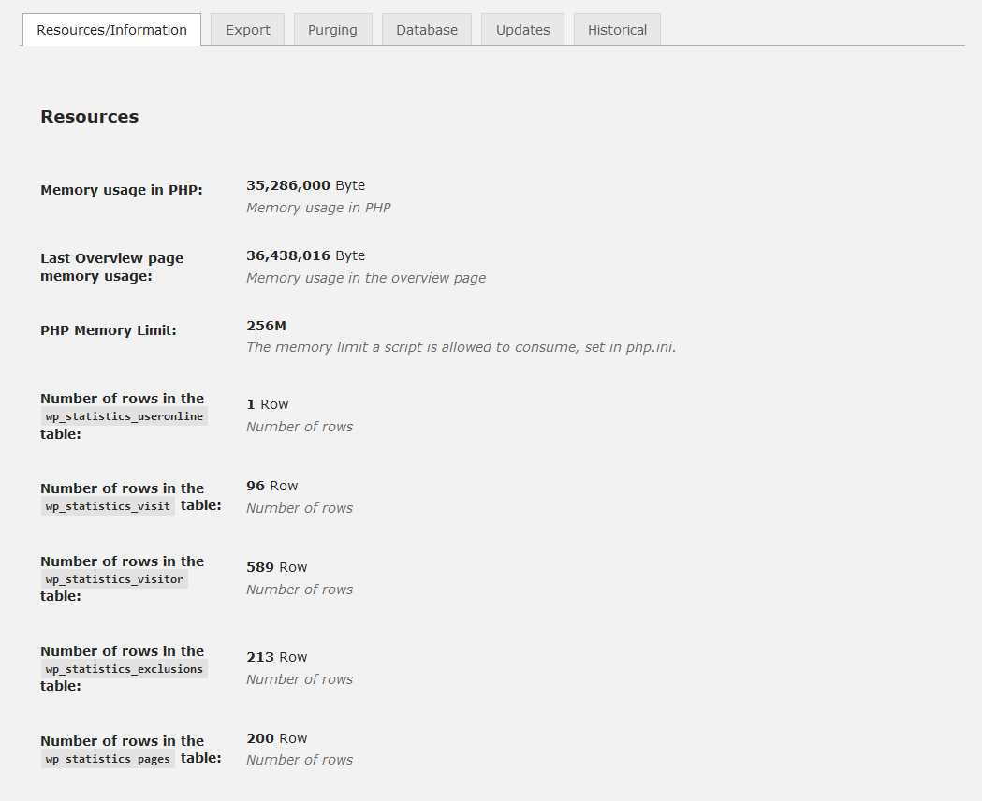
It has six tabs; Resources/Information, Export, Purging, Database, Updates and Historical.

Resources/Information
The Resources/Information page has 4 subsections to it; Resources, Version Info, File Info and Client Info.

Resources
The Resources section contains some resource usage information.
Setting | Values | Description
Memory usage in PHP | Bytes | The number of bytes of memory WordPress is currently using. This number is highly transitive and should only be used as a genera guide line. Pages like the overview page use more memory than others.
Last Overview page memory usage | Bytes | The Overview page in WP Statistics is one of the most memory intensive pages, this value will tell you how much memory was used during the last Overview page load.
PHP Memory Limit | N/A | The maximum amount of memory that PHP will allow a script to use before terminating the script. This value is set in the php.ini file and must be set high enough to allow WP Statistics to load and manipulate data in the statistics charts.
Number of rows in the wp_statistics_useronline table | Rows | The number of rows in the users online table.
Number of rows in the wp_statistics_visit table | Rows | The number of rows in the visits table.
Number of rows in the wp_statistics_visitor table | Rows | The number of rows in the visitors table.
Number of rows in the wp_statistics_exclusions table | Rows | The number of rows in the exclusions table.
Number of rows in the wp_statistics_pages table | Rows | The number of rows in the pages table.
Number of rows in the wp_statistics_historical table | Rows | The number of rows in the historical table.

Version Info
The Version Info section contains the various versions of the software installed on your server.
Setting | Values | Description
WP Statistics Version | Version | The version of the plug-in.
PHP Version | Version | The version of PHP.
PHP Safe Mode | Yes/No | Is PHP running in safe mode. Note this is the value in php.ini, so even though PHP 5.4 and above deprecated safe mode, you may still have the value set in php.ini. If you do, you should remove it.
jQuery Version | Version | The version of jQuery.
cURL Version | Version | The PHP cURL Extension version you are running. cURL is required for the GeoIP code, if it is not installed GeoIP will be disabled.
BC Math | Yes/No | If the PHP BC Math Extension is installed. BC Math is no longer required for the GeoIP code and is listed here only for historical reasons.

File Info
The File Info section contains information about the GeoIP and browscap files. Browscap has two files, the raw ini file downloaded from browscap.org and a cache file generated by the browscap library to improve performance on loading and lookups.
Setting | Values | Description
GeoIP Database | Size/Date | The file size and date of the GeoIP database installed on your system.
browscap.ini File | Size/Date | The file size and date of the browscap.ini installed on your system.
browscap Cache File | Size/Date | The file size and date of the browscap cache file installed on your system.

Client Info
The Client Info section contains some information about your current session.
Setting | Values | Description
Client IP | IP Address | The IP address you are currently connected from.
User Agent | String | Your user agent string.
Browser | String | The detected browser you are running.
Version | String | The detected browser version you are running.
Platform | String | The detected platform you have.

Export
The Export page allows you to export the data from the database to a flat file. This is useful if you want to do additional analysis on the data or need to migrate to another statistics plug-in.
Setting | Values | Description
Export from | Table name | You can export from the three primary data tables.
Export To: | Excel, XML, CSV, TSV | The format to export to.  Excel will export an XML formatted XLS file (you may see a warning from Excel about the file not being in the correct format, you can ignore it).  XML will export an XML formatted file.  CSV will export a comma separated value file.  TSV will export a tab separated value file.
Include Header Row | On/Off | Include a header row as the first line of the exported file.

Purging
The Purging page has 2 subsections to it; Data and Delete User Agent Types.

Data
The Data section allows you to purge information from the database..
Setting | Values | Description
Empty Table | Table name | This will delete ALL data from the selected tables. Only do this if you are absolutely sure you want to reset all of your statistics.
Purge records older than | Number | Deleted user statistics data older than the selected number of days. Minimum value is 30 days. Since WP Statistics 8.2 the pruned data will be summarized in to the historical database.
Purge visitors with more than | Number | Deleted user statistics data where the user has more than the defined number of hits in a day. This can be useful to clear up old data when your site has been hit by a bot.  This will remove the visitor and their hits to the site, however it will not remove individual page hits as that data is not recorded on a per use basis.  Minimum value is 10 hits.

Delete User Agent Types
The Delete User Agent Types section allows you to delete various user agent types from the database. This can be used to remove robots or other types of agents that are not real users.
Setting | Values | Description
Delete Agents | Agent name | This will delete ALL visitors with the selected agent type.
Delete Platforms | Platform name | This will delete ALL visitors with the selected platform.

Database
The Database page allows you to rerun the install routine or add a unique index to the Visitors table to protect against duplicate entries.

Database Setup
If for some reason you have had to delete one or more tables from the database server (perhaps a corrupt table or recovering from an incomplete backup) WP Statistics will warn you that the tables are missing however it will only run the database install/upgrade code during a version change.
This option will let you re-run the WP Statistics setup routine without having to manipulate the WordPress options table or the WP Statistics code.
This should only be done as a last resort.

Database Index
This only needs to be done on older installs and if the index already exists this page will inform you there is nothing to do.
Otherwise you will be presented with a button to add the index to the table.

Updates
The Updates page allows you to update data in the database for GeoIP and Hash IP addresses.

GeoIP Options
Setting | Values | Description
Countries | N/A | Selecting the “Update Now!” button will try and update any missing geolocation information in the visitors table. This can also be automated with the Statistics->Settings->GeoIP->Populate missing GeoIP after update of GeoIP DB setting.  Note if you have selected to hash the IP addresses then this will not function for those entires with hashed values.

IP Addresses
Setting | Values | Description
Hash IP Addresses | N/A | Selecting the “Update Now!” button will replace all IP addresses in the database with hash values.  You will not be able to recover the IP addresses in the future to populate location information if this is selected.

Historical
The Historical page allows you to configure the values to add to the total visits and visitors for your site. These values are auto incremented when any purging of data is done. Purging data also records page hits, however there is no user interface available for changing the values for page entries.
Note that if you use the purge function in the optimization page you should reload the page before editing these numbers as they will not be accurate.

Historical Values
Setting | Values | Description
Visitors | Number | A number of visitors to add to the total number of visitors to your site. This is useful if you have migrated from another statistics plugin or have purged data in the past to give an accurate total visitors count for your site.
Visits | Number | A number of visits to add to the total number of visits to your site. This is useful if you have migrated from another statistics plugin or have purged data in the past to give an accurate total visits count for your site.

Overview Page
The Overview page gives you a quick summary of all the statistics available, it looks like this:
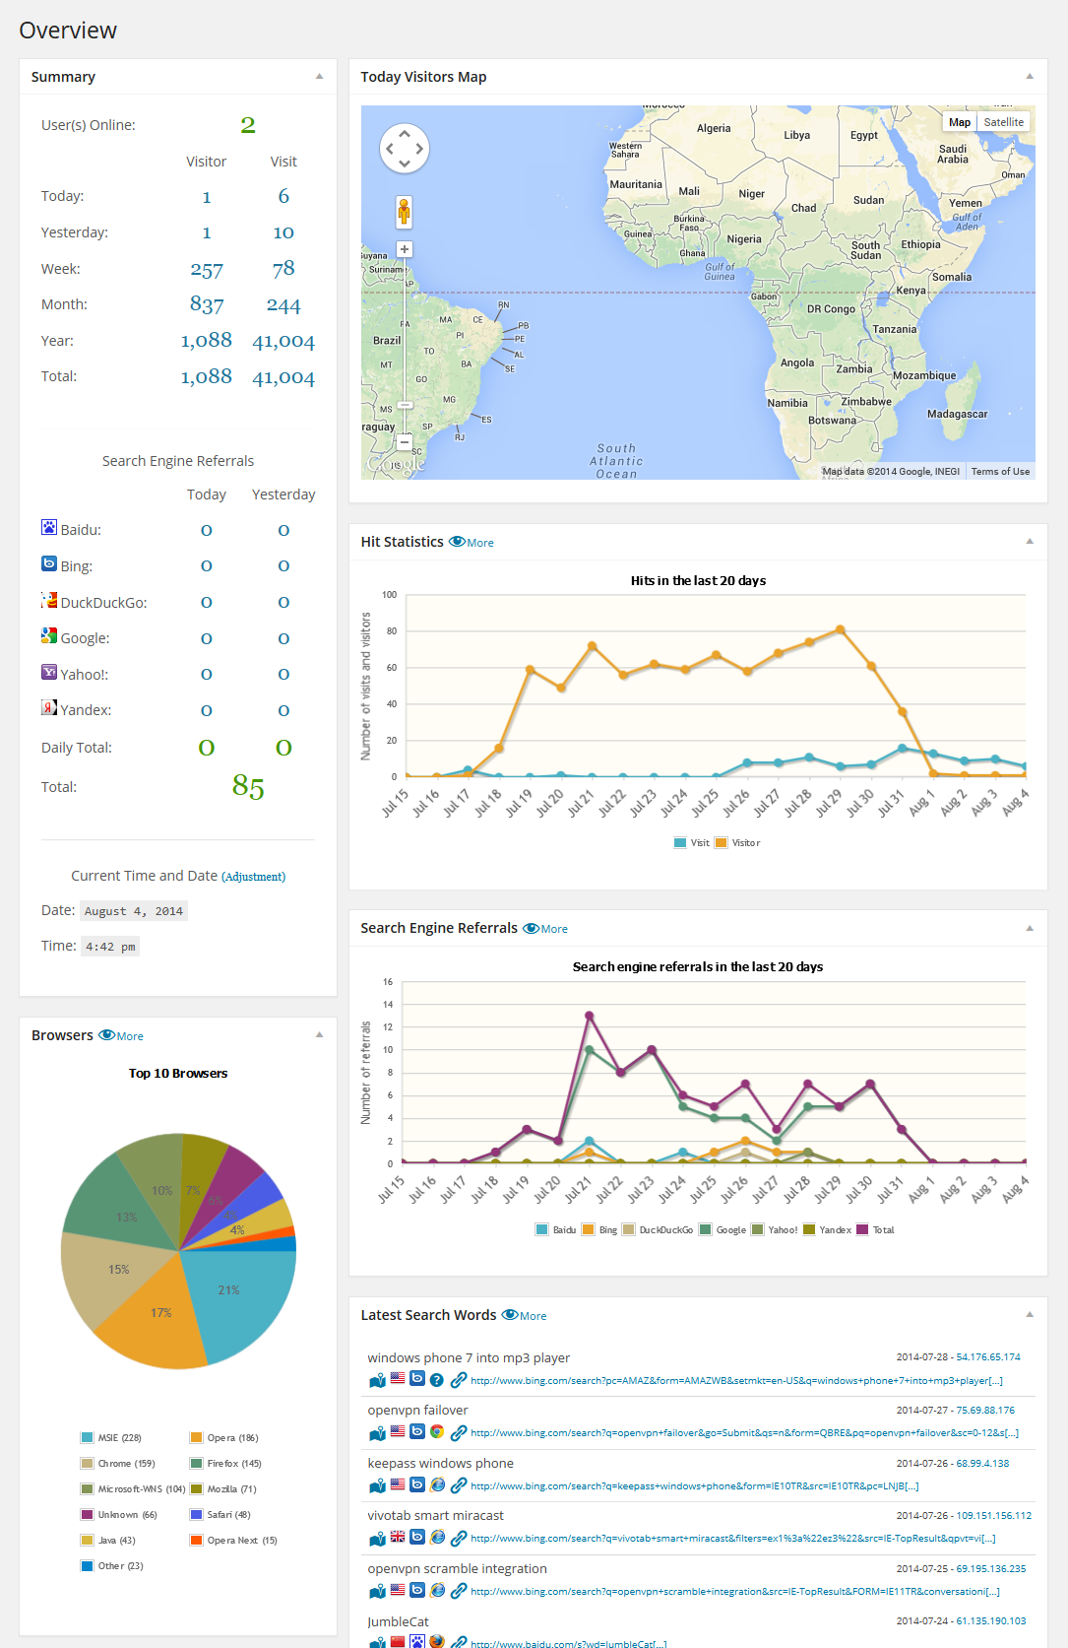
It contains several “widgets” to display information, these are; Summary Statistics, Browsers, Top referring sites, Top 10 Countries, About, Top visitors on map, Hits Statistical Chart, Search Engine Referrals Statistical Chart, Latest Search Words, Top Pages Visited and Recent Visitors.
Each widget is comprised of a header bar and a statistical body. The header contains three areas:
The title (Browsers in the above example), a “more” link (if applicable) and a “Minimize/Maximize” control (on the far right).

The “more” link will take you to a separate page with additional or more comprehensive statistics on the related items.

The “Minimize/Maximize” control will collapse/expand the widget. Note that the state of the widget is not saved between page views so they will re-expand the next time you visit the overview page.

The widgets are as follows:
Widget | Description
Summary Statistics | This displays today's and yesterday's statistics for the site. This includes the number of users currently online, visits, visitors and search engine referrals.  This widget also displays the current date and time (at page load). WP Statistics relies on the correct date and time as well as timezone being set on the server and in WordPress to display the correct information.
Top 10 Browsers | This displays a pie chart (not configurable) of the top ten browser types that have visited your site.
Top Referring Sites | This displays the top 10 sites that have referred visitors to your site.
Top 10 Countries | This displays the top 10 countries of the visitors to your site.
About | This provides some details about the plug-in and the donation links.
Today Visitors Map | This displays your visitors today on a Google map. This requires the GeoIP code to be enabled. You can use either Google or JQVMap mapping libraries (see Statistics->Settings->Overview->Maps). To keep the maps readable, the last five visitors per country are displayed on the map.
Hits Statistics | This displays your visit and visitor counts in a graph format for the last 20 days.
Search Engine Referrals | This displays the number of referrals you have received from search engines for the last 20 days.
Latest Search Words | This displays the last 10 search words referred to your site by search engines. Note that this is highly dependent on the search engine providing the information, some do not.
Top 10 Pages | This displays the top 10 pages that are visited for your site.
Recent Visitors | This displays the last 10 visitors to your site. This includes options to map their location, what country they came from and what browser they are using.
Top 10 Visitors Today | This displays the top 10 visitors today based on the number of times they have visited the site today. The display includes the visitors location, ip and browser details.

Browsers Page
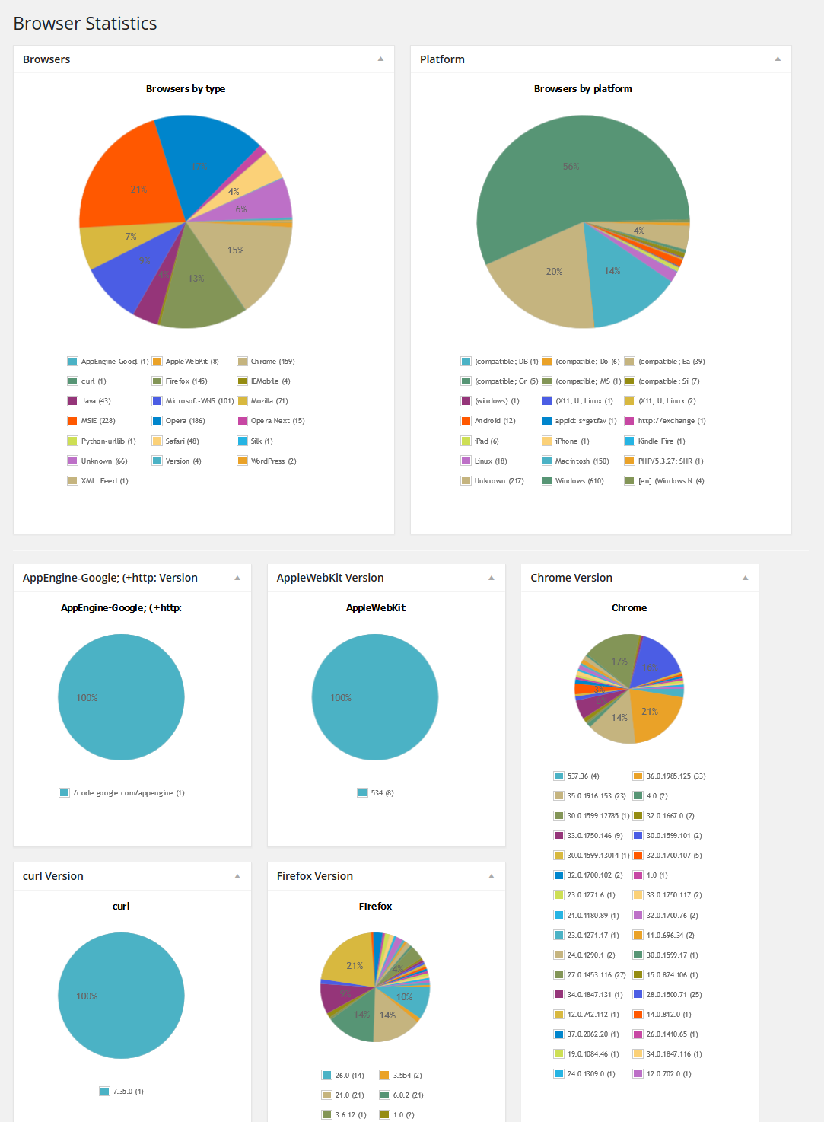
This page provides details about the browsers users are using to visit your site. This information is presented in a series of pie charts.

The first two pie charts provide details on the browser type and platform used. The rest of the pie charts identify different version of browsers used.

Countries Page
This page provides details about the countries of users that have visited your site.
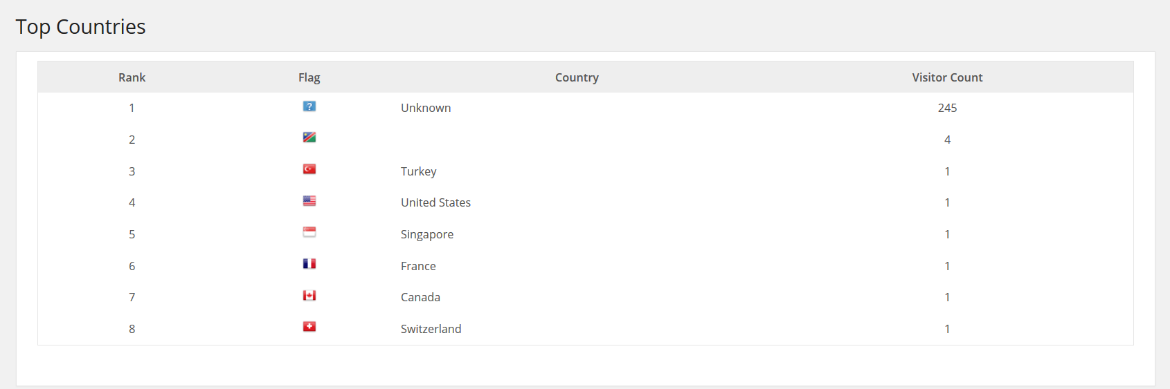
This chart will list all countries and includes the number of visitors from each.

Exclusions Page
This page provides a trending chart for the exclusion reasons if Statistics->Settings->Record Exclusions is enabled.
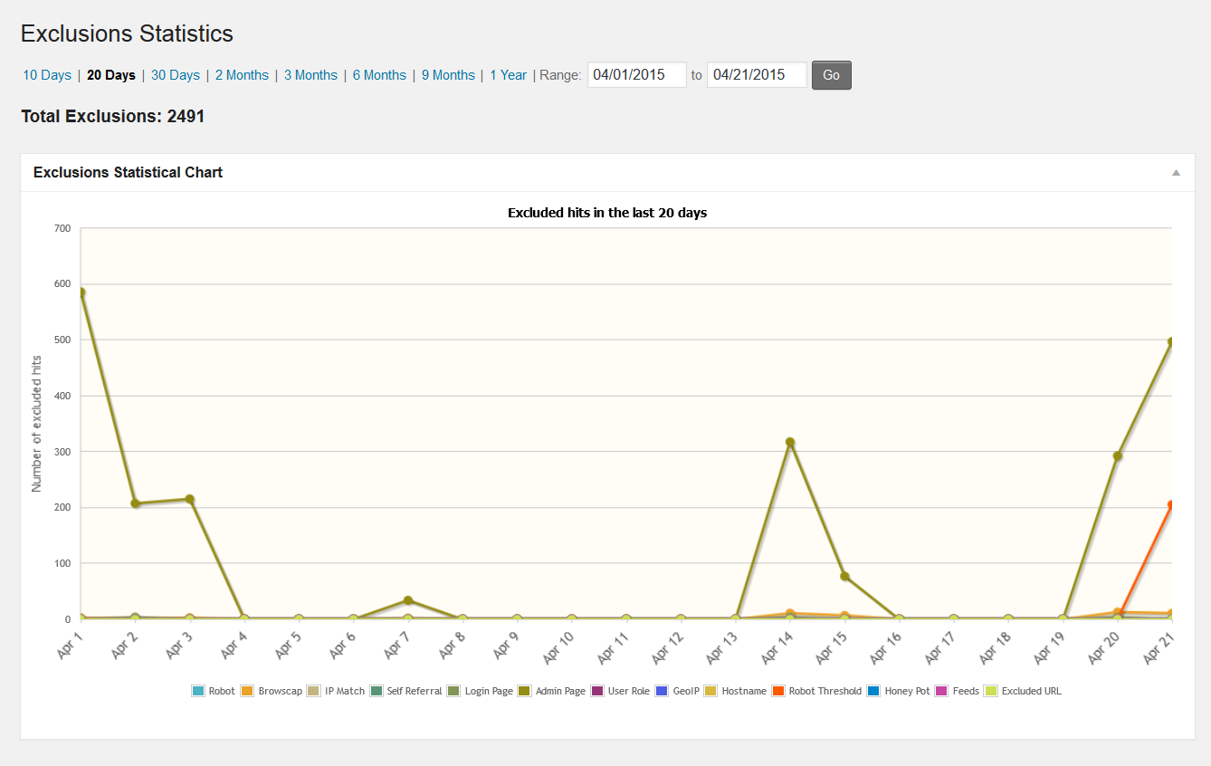
The top part of the page allows you to select from
- 10, 20, 30 days increments
- 2, 3, 6, 9 months increments
- 1 year increment
- Range, an arbitrary range of dates to graph
Note that the longer the increment is the more data that is required to be processed. Large site with long increments can take significant time and memory to process.

Hits Page
This page provides a trending chart for the total visitors to your site over a selectable time line.
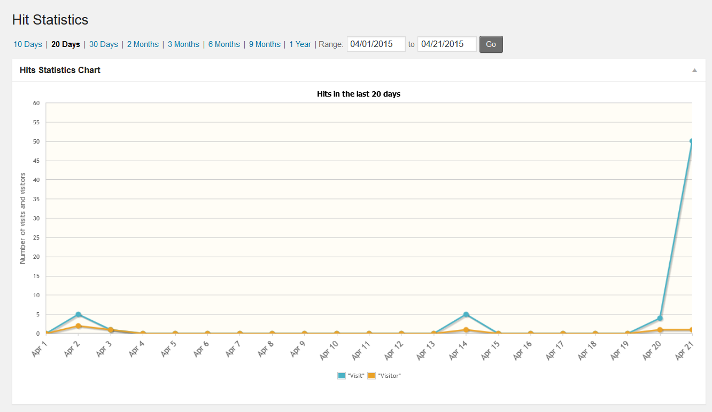
The top part of the page allows you to select from
- 10, 20, 30 days increments
- 2, 3, 6, 9 months increments
- 1 year increment
- Range, an arbitrary range of dates to graph
Note that the longer the increment is the more data that is required to be processed. Large site with long increments can take significant time and memory to process.

Online Page
This page provides a list of users that are currently online and how long they have been online for.
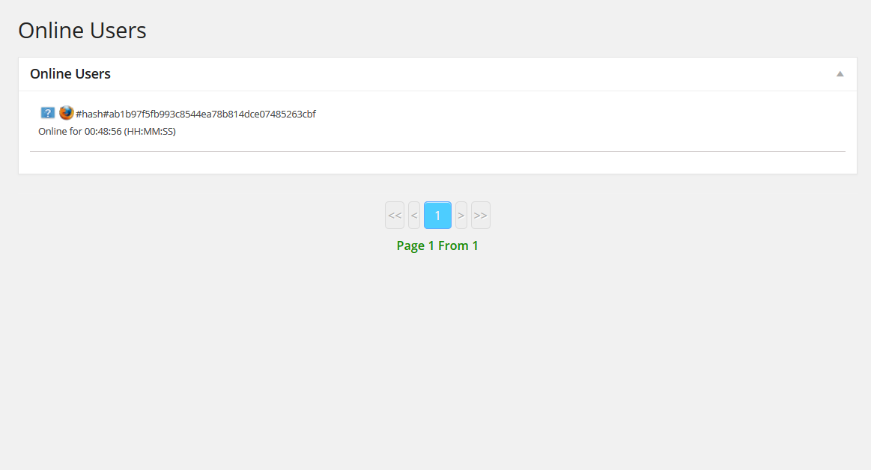

Pages Page
This page provides trending graph of your top five pages over the last 20 days as well as a complete list of all your page rankings divided up in to groups of 10.
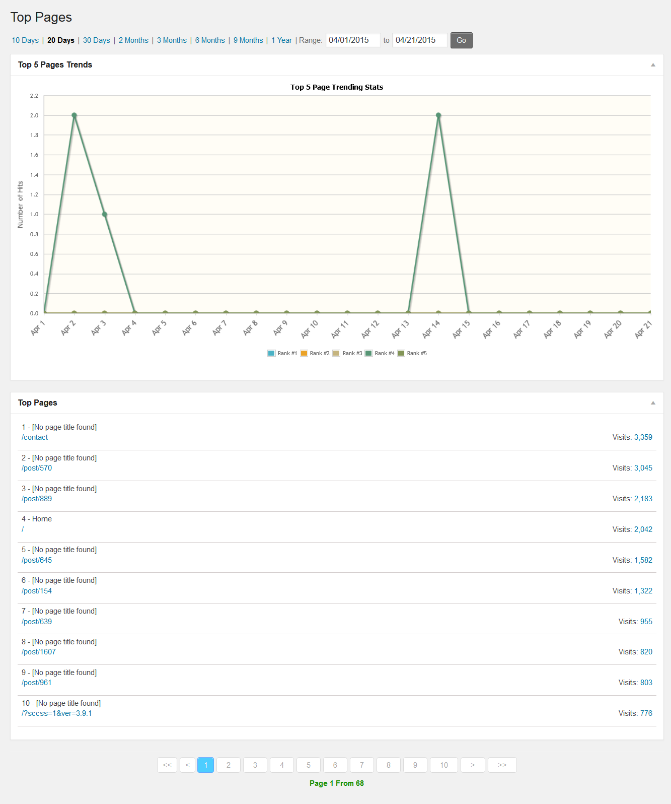
The top part of the page allows you to select from
- 10, 20, 30 days increments
- 2, 3, 6, 9 months increments
- 1 year increment
- Range, an arbitrary range of dates to graph
Note that the longer the increment is the more data that is required to be processed. Large site with long increments can take significant time and memory to process.
The time selection only effects the display of the chart on this page and not the page list at the bottom of the page.
The list of pages contains the rank, page title (not all pages will have titles), the URI of the page and the number of visits. The number of visits is a link to a more detailed trending graph for that page.
The detailed trending page looks like:
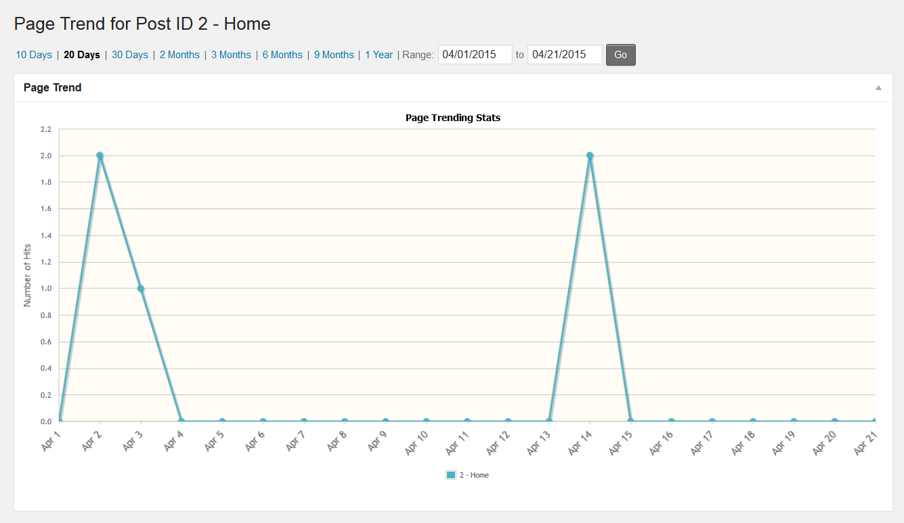
The time frame is selectable by the links at the top of the page. This trending view is available to all pages in the pages list as well as, if not disabled, the hits count in the page/posts list and editor in WordPress.

Referrers Page
This page provides a complete list of all referrers to your site.
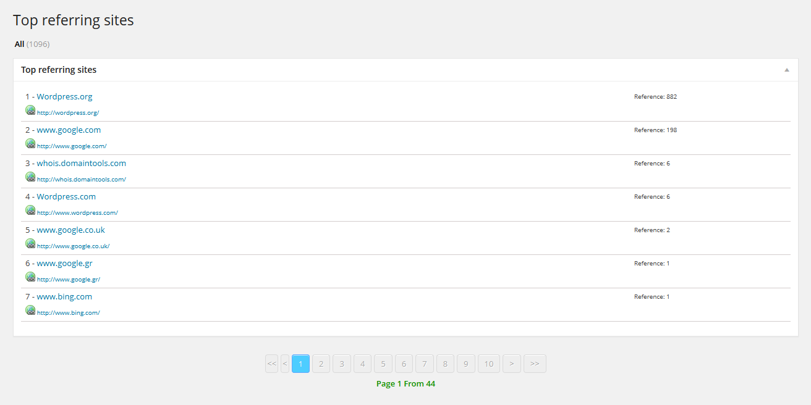
It is divided up in to pages of 10 entries each for easy browsing.

Searches Page
This page provides a trending graph of all incoming search engine traffic to your site.
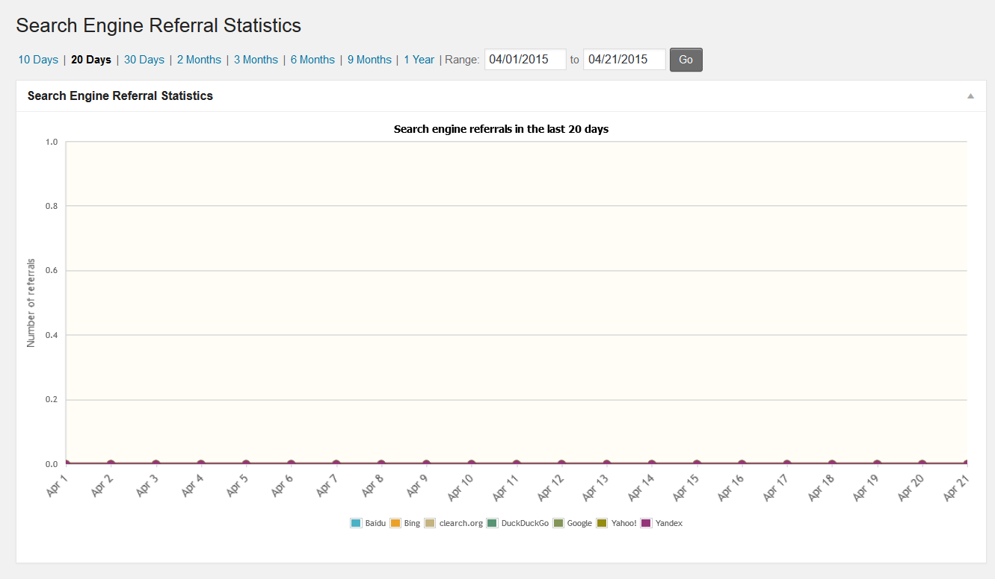
The top part of the page allows you to select from
- 10, 20, 30 days increments
- 2, 3, 6, 9 months increments
- 1 year increment
- Range, an arbitrary range of dates to graph

Note that the longer the increment is the more data that is required to be processed. Large site with long increments can take significant time and memory to process.

Search Words Page
This page provides a list of all search words from search engines to your site.
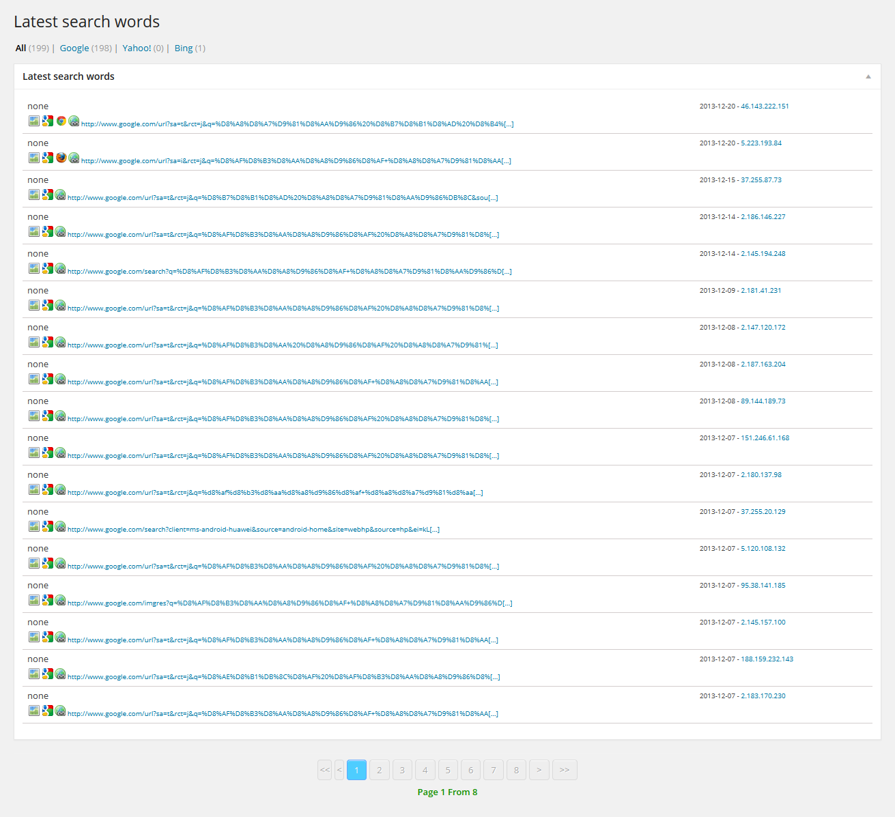
It is divided up in to pages of 20 entries each for easy browsing.

Top Visitors Today
This page provides a list of the top 100 visitors to your site today.
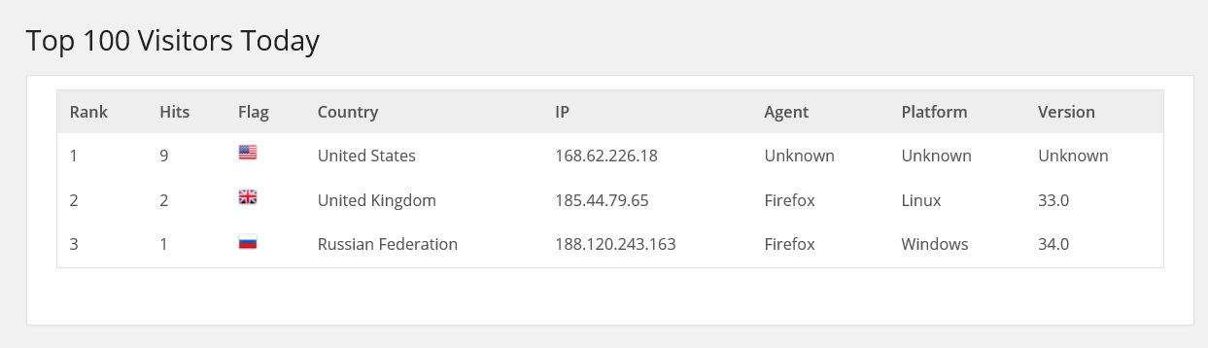
It is divided up in to pages of 20 entries each for easy browsing.

Visitors Page
This page provides a list of all vistors to your site.
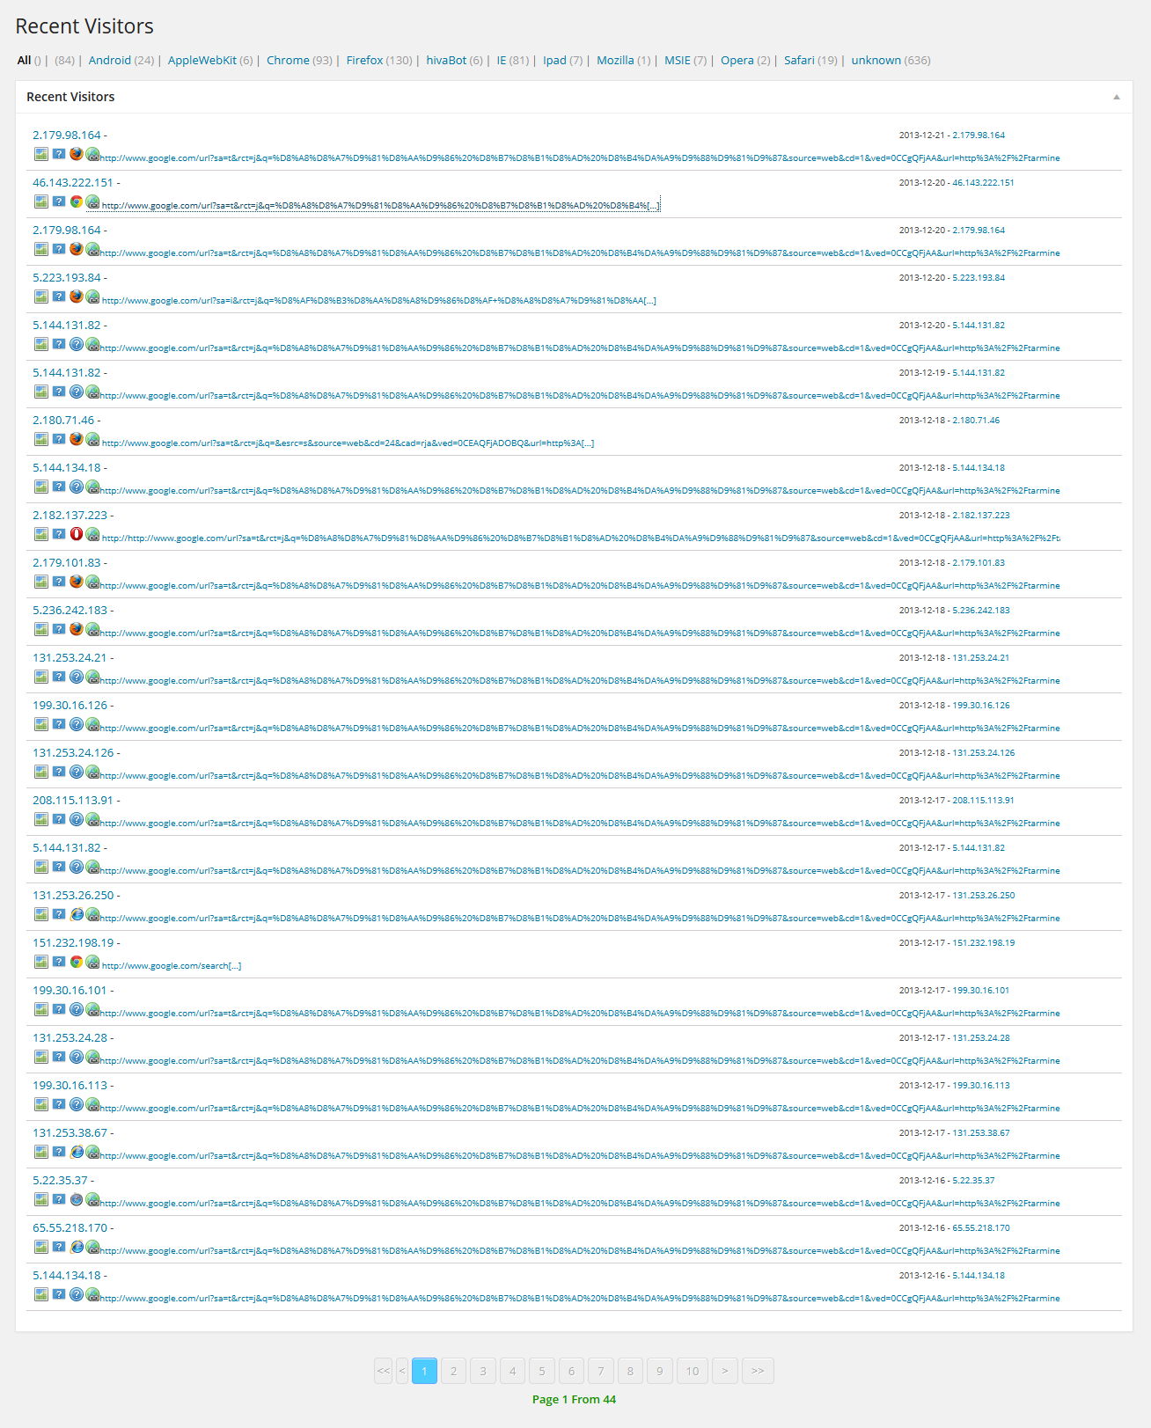
It is divided up in to pages of 20 entries each for easy browsing.

Multi-Site
WordPress multi-site allows you to run multiple independent sites from a single WordPress installation.
WP Statistics does not fully support multi-site at this time but does have some basic options available for multi-site installations.
The key areas of support are currently:
- Installation
- Updates
- Removal
- Basic network menu

Multi-Site Installation
Installing WP Statistics on a multi-site installation is much like on a standalone WordPress setup. Each site will have it's own database tables and options for WP Statistics which can be configured on the site dashboard.
As long as you install WP Statistics with an account that has rights across the network, the database tables will be automatically created for each site. If your installation account does not have rights to one or more of the child sites, you can manually run the installation routine by logging in with an account that does have rights and re-running the install process manually from the Statistics->Settings menu for the site.

Multi-Site Updates
Much like instllation, updates will automatically update any database tables and settings as required as long as the account you are using to upgrade with has rights to the child sites. If your account does not have rights to one or more of the child sites, you can manually run the installation routine by logging in with an account that does have rights and re-running the install process manually from the Statistics->Settings menu for the site.

Removal
Removal is accomplished the same way as for single installs and supports multi-site.

Network Menu
The network admin page looks much like the standard WordPress admin page, however it has some significant differences. WP Statistics has a basic implementation of the network menu to allow an administrator some additional functions that may be of use in multi-site installations.
The primary WP Statistics menu in the network admin page looks like this:
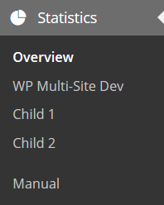
The first entry is the overview page, it will be discussed later.
The next set of entries are each of your sites in the network, up to a maximum of 15. Clicking on any of these menu entries will take you to the overview page on the sites admin page.
The final entry is the manual, if it is installed.

Network Menu Overview Page
The Network Menu Overview Page provides a list of all your sites as well as quick links to the vairous WP Statistics pages for each.
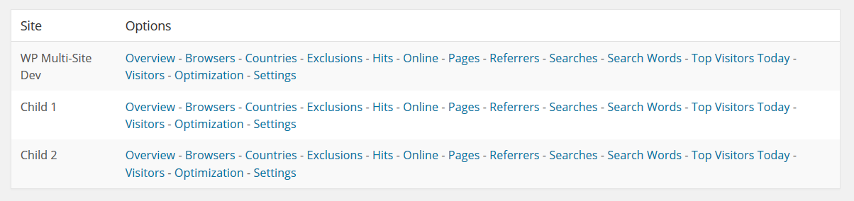
This page is not limited to 15 entries and will show you all of your sites no matter how many you have.

The Widget
WP Statistics comes with a WordPress widget to display some statistical information to your front end. The widget is still supported, however you may find the shortcodes to be more useful as they can be used in an HTML widget with any custom formatting you may like to apply.

The widget is called “Statistics” and the configuration page looks as follows:
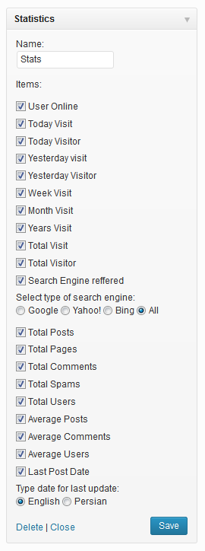
The name field at the top will be displayed in the header of the widget on your site. Each option that is enabled will be displayed on a single line in the widget and display the indicated information.

Shortcodes
WP Statistics supports shortcodes in WordPress, these can be used in either a post and page body as well as an HTML widget.
The general shortcode format is:
[wpstatistics stat=xxx time=xxxx provider=xxxx format=xxxxxx]
Where:
Item | Description
stat | The statistic you want, see the next table for available options.
time | Is the time frame for the statistic. This value uses the strtotime() PHP function (http://php.net/manual/en/datetime.formats.php) format, some acceptable values include:  - today  - yesterday  - week  - month  - year  - total  - "-x" (i.e., "-10" for the past 10 days)  Please refer to the PHP manual link above for a complete description.
provider | The search provider to get stats on (bing/duckduckgo/google/yahoo/yandex).
format | The format to use for numbers, the options are i18n (uses the format of the current country as set in WordPress), english (uses 1,000.00 style formats) or none (the default will return an number without any formating)
The “stat” field can be any of the following:
Stat | Description
usersonline | The number of users online right now.
visits | The number of hits to the site.
visitors | The number of visitors to the site.
pagevisits | The number of times the current page has been visited
searches | The number of search engine referrals.
postcount | The total number of posts on the site.
pagecount | The total number of pages on the site.
commentcount | The total number of comments on the site.
spamcount | The total number of spam comments on the site.
usercount | The total number of users on the site.
postaverage | The average posts per user on the site.
commentaverage | The average comments per user on the site.
useraverage | The average number of users on the site.
lpd | The last post date for the site.
Examples:
- [wpstatistics stat=usersonline]
- [wpstatistics stat=visitors time=today]
- [wpstatistics stat=visits time=today]
- [wpstatistics stat=visitors time=yesterday]
- [wpstatistics stat=visits time=yesterday]
- [wpstatistics stat=visitors time=total]
- [wpstatistics stat=visits time=total]

Function API
WP Statistics supports several functions for other plug-in and theme authors to use to retrieve statistics about the site. All of the external functions can be found in:
wp-statistics\includes\functions\functions.php

Function | Description
wp_statistics_useronline() | Get the number of users online
wp_statistics_visitor(time) | Get the number of visitors
wp_statistics_visit(time) | Get the number of visits (hits)
wp_statistics_pages(time,uri,id) | Get the page views for a given page
wp_statistics_uri_to_id(uri) | Get the page ID of a given uri
wp_statistics_get_top_pages() | Get all pages sorted by number of hits (high to low)
wp_statistics_get_uri() | Get the current page's uri
wp_statistics_searchengine(provider, time) | Get the number of search engine referrals
wp_statistics_ua_list() | Retrieve a list of all visitors user agents
wp_statistics_useragent(agent) | Retrieve the number of visits from users with a specific user agent
wp_statistics_platform_list() | Retrieve a list of all visitors platforms
wp_statistics_platform(platform) | Retrieve the number of visits from users with a specific platform
wp_statistics_agent_version_list(agent) | Retrieve a list of all visitors agent versions
wp_statistics_agent_version(agent, version) | Retrieve the number of visits from users with a specific agent version
wp_statistics_searchengine_list(all) | Retrieve a list of search engines, by default this only returns search engines that are active, setting all to TRUE will return ALL search engines
wp_statistics_searchword_query (search_engine) | Returns the SQL query portion to find all search word queries for a given search engine
wp_statistics_searchengine_query (search_engine) | Returns the SQL query portion to find all search engine results for a given search engine
wp_statistics_searchengine_regex (search_engine') | Returns the regex to determine if a Referral URL is from a search engine
wp_statistics_countposts() | Total number of posts on your site
wp_statistics_countpages() | Total number of pages on your site
wp_statistics_countcomment() | Total number of comments on your site
wp_statistics_countspam() | Total number of spams items on your site
wp_statistics_countusers() | Total number of users on your site
wp_statistics_lastpostdate() | Last post date
wp_statistics_average_post() | Average number of posts
wp_statistics_average_comment() | Average number of comments
wp_statistics_average_registeruser() | Average number of users

Where:

Item | Description
time | Is the time frame for the statistic. This value uses the strtotime() PHP function (http://php.net/manual/en/datetime.formats.php) format, some acceptable values include:  - today  - yesterday  - week  - month  - year  - total  - "-x" (i.e., "-10" for the past 10 days)  Please refer to the PHP manual link above for a complete description.
provider | The search provider to get stats on (bing/duckduckgo/google/yahoo/yandex).
uri | The uri of the page you want to get statistics for. This should only be the portion of the URI after your WordPress base directory. So if the full URL of the page you want is:  http://example.com/wordpress/index.php?p=5  then the uri field should be:  /index.php?p=5
id | The post or page id you want to get statistics for.

